ISO 27001 implementation guide for HSBC

HSBC is a financial bank which allows peoples to save money, transact money account to account and it allows online shopping. Therefore, it should be protected. In this task we are going to implement ISO 27001 standard to HSBC. First, we should identify the steps of ISO 27001 implementation.

1. Assemble an implementation team
2. Develop the implementation plan
3. Initiate the ISMS
4. Define the ISMS Scope
5. Identify Security baseline
6. Establish a risk management process
7. Set up policies and procedures to control risks
8. Monitor and review
9. Prepare for an internal audit
10. Periodic management review
11. Assemble an implementation team.

First, we must designate a leader to the who have strong understanding in information security and execution of ISMS (Information security management system) (Information security management system). Leader has power to lead the team provide commands to team members and management.

The team members are chosen by senior management, or the team leader may choose the team members on his own. When the team has been assembled, they should draft a project proposal that outlines the goals for the endeavor as well as the potential advantages for HSBC. The proposal should also include information on the project's timeline, budget, and management support.

1. Develop the implementation plan

The group must devise a strategy for putting ISO 27001 standards into practice. The implementation team uses the project mandate to create a more detailed explanation of its information security goals, approach, risk register, and asset register.

It will discuss roles and duties at HSBC, how to increase awareness about the program both internally and externally.

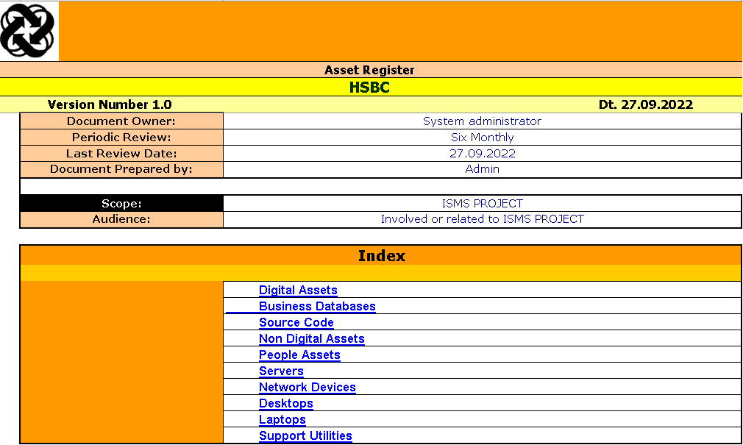

1. Brief ISMS policy

The ISMS policy paper is the most important and highest level document. It need not be complicated, only some basic data regarding HNHSBC's information security management system will do. The goal of an ISMS Policy is to help management make clear to staff members and resources what has to be done and how it may be handled.

1. Define the ISMS scope

The ISMS policy paper is the most important and highest level document. It need not be complicated, only some basic data regarding HNHSBC's information security management system will do. The goal of an ISMS Policy is to help management make clear to staff members and resources what has to be done and how it may be handled.

1. Identify Security baseline

This is the minimal degree of activity necessary for secure HSBC bank operations. The implementation team may select HSBC security baseline with information in ISO 27001 risk assessment. This will aid the implementation team's comprehension of HSBC's security flaws and the ISO 27001 measures designed to address them.

1. Establish a risk management process

This is the heart of an ISMS. Nearly each component of HSBC safety system is primarily based around the threats implementation team have recognized and prioritized, making danger management a core competency for any enterprise implementing ISO 27001. This is a five-step process,

1.Establish a risk assessment framework

2.Identify risks

3.Analys risks

4.Evaluate risks

5.select risk management options

Then need to set up danger attractiveness standards. The damage that threats will reason and the probability of them going on. There are four processes you can take while addressing a risk,

1.Tolerate the threat

2.Apply controls

3.Terminate the danger by fending off it absolutely

4.Transfer the risk

Then implementation team must come up with statement of applicability (SoA). This document has standard’s controls the implementation team selected and not selected and why they made that selections.

1. Set up policies and procedures to control risks

No matter how long it has been in business, HSBC must maintain user responsibility records and detailed methods or declarations of policy for the controls it has deployed. In order to apply these policies and procedures consistently, effectively, and practically, the agency would be able to define user roles and responsibilities.

The precise documenting of legislation and techniques is essential by employing ISO 27001. However, the list of guidelines and their applicability depends on the geographical area, resources, and common structure of the business enterprise.

1. Monitor and review

The implementation team won’t be able to clarify that ISMS is operating or not unless they review it. This has to be done at least once a year. Finding standards that reflect the objectives you stated in the project mandate is a necessary step in the evaluation process.

There is no specific technique to perform an ISO 27001 audit, thus it is possible to undertake the assessment for one department at a time. The implementation team must conduct routine internal audits of the HSBC ISMS. Internal audit's outcomes influence the inputs for the control assessment, which is a useful approach to feed information into the chronic improvement technique.

1. Prepare for an internal audit

The majority of the time, employees in any business enterprise commit unlawful acts, whether knowingly or unknowingly, which harm the business's performance and reputation. An internal audit must be carried out in order to identify these present and capability problems. The goal of an internal audit is to initiate any necessary corrective or preventative activities, as well as any necessary disciplinary proceedings against the workers.

1. Periodic management review

Instead of creating and constructing a firewall for information security, management only needs to be aware of what is happening inside the ISMS and how effectively and efficiently the rules and procedures are implemented. Control assess incorporates whether or not the recommendations of ISMS are being followed or not and if intended repercussions are been finished or now not. Control bases important judgments on these assumptions.